2. Configure Apache Webserver on AWS Linux EC2 Machine  
Result:  
Display "K21Academy is one of the best places to learn cloud" after entering the URL

* Go to EC2 dashboard click on “Launch Instance”
* Give a Name to the instance.  
  Select the AMI “ami-051ed863837a0b1b6" for amazon Linux
* **Instance type-**

T2.micro - Its free tire eligible and it will be best for hosting a demo website. For other tasks like HCP different series like “C” will be the best.

* **Key pair (login)**

Create a new Key pair for accessing the instance for the first time or we can use a existing Key as well.

* **Network settings**

This decides where the instance will be launched. I have launched it in default, but we can create our VPC and launch the instance there and I have allows HTTP form anywhere that is 0.0.0.0/0 and SSH can be allowed from my IP or customizer IP as per requirements.

* **Configure storage**  
  By default AWS attached one 8 GB gp3 storage with the instance. This is like a hard disk which will store and host the apache server.
* **Advanced details**

We can even add all the Linux commands in “User data” and launch the instance. As soon as the instance is launched the command entered in User data will start running automatically but we have done it manually for better understanding.

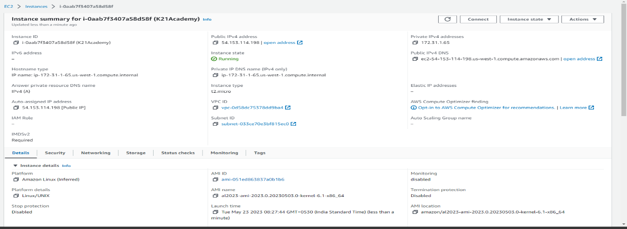

Then Connect to the instance and run the following commands.

1. sudo yum upgrade- To upgrade Linux.
2. sudo yum update- To update Linux.
3. sudo yum install httpd-To install apache server.
4. vim /var/html/index.html – insert the following html code.

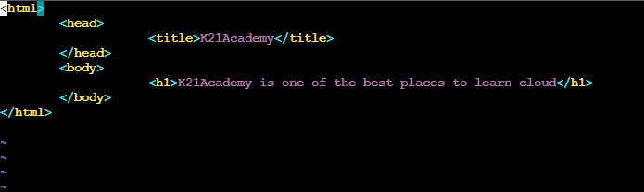

5. sudo service httpd start – to start httpd server

6. sudo chkconfig httpd on – to manage the system service and Run levels

Copy the public ID and paste it in browser.

The public ID is 54.153.114.198 where the Website is still hosted.

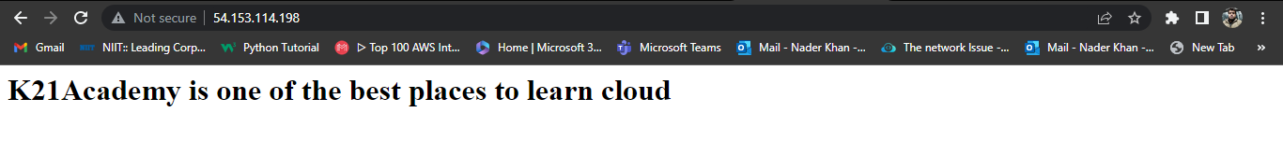

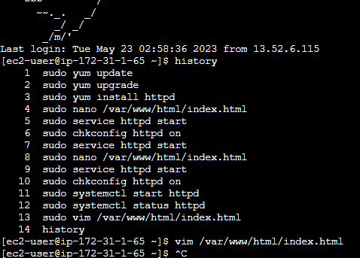

You can also recreate the following using the following EC2.tf file attached with the mail.